CS 305 Project One Template

Document Revision History

Version | Date | Author | Comments
1.0 | 9-20-2026 | Stephen Zelske

Client



Instructions
Submit this completed vulnerability assessment report. Replace the bracketed text with the relevant information. In this report, identify your security vulnerability findings and recommend the next steps to remedy the issues you have found.

- Respond to the five steps outlined below and include your findings.
- Respond using your own words. You may also include images or supporting materials. If you include them, make certain to insert them in the relevant locations in the document.
- Refer to the Project One Guidelines and Rubric for more detailed instructions about each section of the template.

Developer
Stephen Zelske

1. Interpreting Client Needs
Determine your client’s needs and potential threats and attacks associated with the company’s application and software security requirements. Consider the following questions regarding how companies protect against external threats based on the scenario information:

- What is the value of secure communications to the company?
- Are there any international transactions that the company produces?
- Are there governmental restrictions on secure communications to consider?
- What external threats might be present now and in the immediate future?
- What modernization requirements must be considered, such as the role of open-source libraries and evolving web application technologies?

The value of secure communications to Artemis Financial is crucial to their software requirements. With client’s personal information and money information transferred data, it is important to make sure that the data is safe and secure. There are no indicators if Artemis Financial produces international transactions, but working with a global consulting firm, it is safe to assume there are currency exchanges. When money is involved, it is safe to assume that there are governmental restrictions on secure communications to consider. Are there any taxes on any of the transactions being made? How does this get communicated to the company and its clients? Also, there must be other governmental restrictions to consider with any transactions that happen from one country to another. The external threats that might be present now and in the immediate future would be the client’s information being targeted for use in a scam. The modernization requirements that must be considered is the constant updating to fix any security vulnerabilities that may be found in the current system. Constantly updating and making sure every security patch is installed to keep the software secure.

2. Areas of Security
Refer to the vulnerability assessment process flow diagram. Identify which areas of security apply to Artemis Financial’s software application. Justify your reasoning for why each area is relevant to the software application.

Input Validation: Customers must enter a valid first and last name. Then also enter a valid e-mail address that is linked to their account, along with a 10-character minimum password that includes at least one capital letter, one numeric character, and one special character. This helps with the first line of defense to ensure only registered customers can log in.

APIs: Ensuring that the financial data is secure when moving from one system to a database or to another system.

Cryptography: Encrypting clients’ data and ensuring that it is encoded to help protect from attackers.

Encapsulation: Restricting direct access to the data can provide another layer of protection to the financial data from attackers.

3. Manual Review
Continue working through the vulnerability assessment process flow diagram. Identify all vulnerabilities in the code base by manually inspecting the code.

CWE-347 Improper Verification of Cryptographic Signature
CWE-362 Concurrent Execution using Shared Resource with Improper Synchronization ('Race Condition')
CWE-400 Uncontrolled Resource Consumption
CWE-200 Exposure of Sensitive Information to an Unauthorized Actor
CWE-310 Cryptographic Issues
CWE-94 Improper Control of Generation of Code ('Code Injection')
CWE-79 Improper Neutralization of Input During Web Page Generation ('Cross-site Scripting')

4. Static Testing
Run a dependency check on Artemis Financial’s software application to identify all security vulnerabilities in the code. Record the output from the dependency-check report. Include the following items:

- The names or vulnerability codes of the known vulnerabilities
- A brief description and recommended solutions provided by the dependency-check report
- Any attribution that documents how this vulnerability has been identified or documented previously

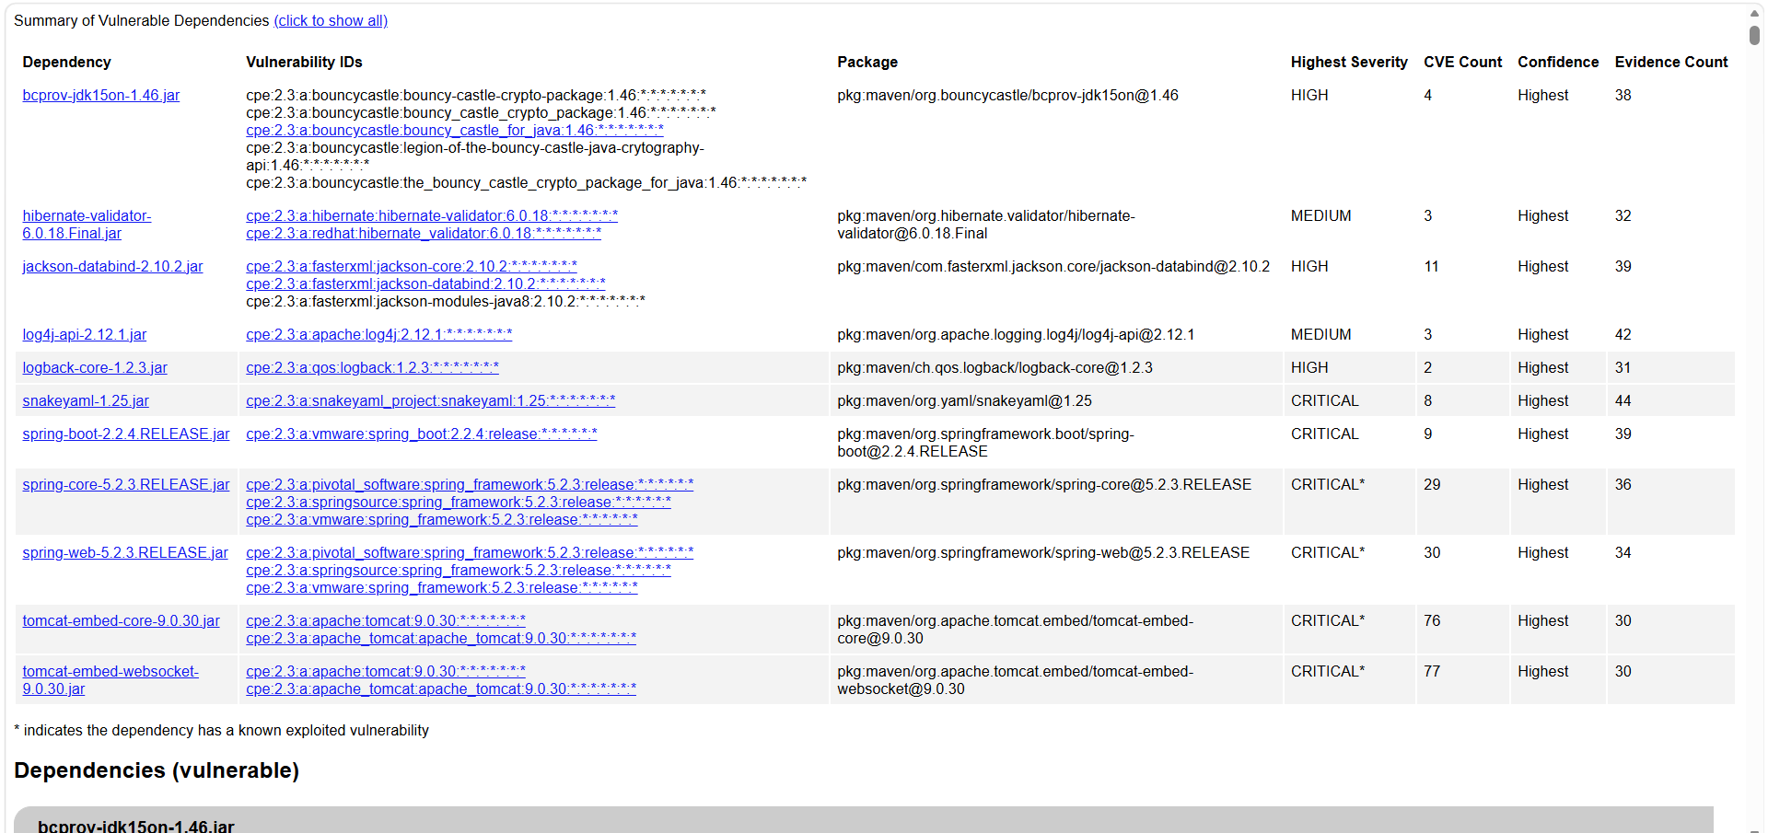

CVE-2016-1000338: In Bouncy Castle JCE Provider version 1.55 and earlier the DSA does not fully validate ASN.1 encoding of signature on verification. It is possible to inject extra elements in the sequence making up the signature and still have it validate, which in some cases may allow the introduction of 'invisible' data into a signed structure.

CVE-2020-15522: Bouncy Castle BC Java before 1.66, BC C# .NET before 1.8.7, BC-FJA before 1.0.1.2, 1.0.2.1, and BC-FNA before 1.0.1.1 have a timing issue within the EC math library that can expose information about the private key when an attacker is able to observe timing information for the generation of multiple deterministic ECDSA signatures.

CVE-2023-33202: Bouncy Castle for Java before 1.73 contains a potential Denial of Service (DoS) issue within the Bouncy Castle org.bouncycastle.openssl.PEMParser class. This class parses OpenSSL PEM encoded streams containing X.509 certificates, PKCS8 encoded keys, and PKCS7 objects. Parsing a file that has crafted ASN.1 data through the PEMParser causes an OutOfMemoryError, which can enable a denial of service attack. (For users of the FIPS Java API: BC-FJA 1.0.2.3 and earlier are affected; BC-FJA 1.0.2.4 is fixed.)

CVE-2015-7940: The Bouncy Castle Java library before 1.51 does not validate a point is withing the elliptic curve, which makes it easier for remote attackers to obtain private keys via a series of crafted elliptic curve Diffie Hellman (ECDH) key exchanges, aka an "invalid curve attack."

CVE-2025-35036: Hibernate Validator before 6.2.0 and 7.0.0, by default and depending how it is used, may interpolate user-supplied input in a constraint violation message with Expression Language. This could allow an attacker to access sensitive information or execute arbitrary Java code. Hibernate Validator as of 6.2.0 and 7.0.0 no longer interpolates custom constraint violation messages with Expression Language and strongly recommends not allowing user-supplied input in constraint violation messages. CVE-2020-5245 and CVE-2025-4428 are examples of related, downstream vulnerabilities involving Expression Language interpolation of user-supplied data.

5. Mitigation Plan
Interpret the results from the manual review and static testing report. Then identify the steps to mitigate the identified security vulnerabilities for Artemis Financial’s software application.

The steps to mitigate the identified security vulnerabilities involve looking at the static testing report and addressing the vulnerabilities with the highest risk severity. Implementing patches to fix the vulnerabilities and address these security risks is critical to the evolution of this software. Ensuring valid input and validation of the client’s login credentials is one of many layers of defense the company must use in their software concerning financial data. With an application that runs on the web and accesses databases concerning client’s financial information, it is important to ensure the data transfers are secure and have as may layers of defense as possible while defending from attackers and staying compliant with any government regulations and policies.

